#Giving Tuesday Kids
DIY Seed Bombs Recipe
Have you ever heard of seed bombs? Basically, they are balls made from clay, soil, and seeds. They can be tossed anywhere you have a large area you’d like to cover with flowers, etc.

You’ll need:

- Air Dry Clay- (if dry add a tsp. of water at a time until it’s moist again)
- Potting Soil
- Flower Seeds
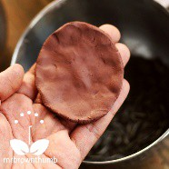

Directions:
  - Take a pinch of your seed bomb clay in your hand and flatten it out.

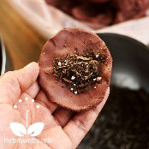
  - Next, place a pinch or more of seed bomb soil in the center of your flattened-out piece of clay.

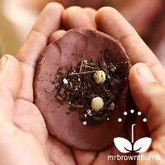

  - Place several seeds to the top of the soil.
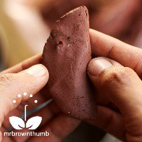
  - Once you have added soil and seeds to your piece of clay it is time to start rolling it into a ball. Start making a seed bomb by folding it as if you were making taco. Once you have the seed bomb soil and seeds safely enclosed in the clay start to work them into the shape of a ball with the palms of your hand.

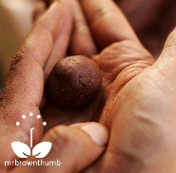
  - Keep rolling the seed bomb ingredients and working them into a ball shape in the palm of your hand. If you find that some of the soil starts to break through the clay, just keep rolling the ball into your hand and incorporating the soil back in the ball. That's all there is to rolling a seed bomb.

