Rules & Entry Form for the
2021 Georgia Farm Bureau
Quality Bermudagrass Hay Contest

The purpose of the contest is to encourage and promote quality hay production. The contest is open only to Georgia Farm Bureau members who produce dry Bermudagrass hay (all types/varieties) on their farm. The entry fee is $20 per sample and is required to cover the cost of lab analysis.

All entries will be tested at the University of Georgia using the Relative Forage Quality (RFQ) system to determine total digestibility. It is imperative that each sample be as dry as possible before sealing in the zip lock bag. High moisture will accelerate the build-up of mold on the sample and will cause it to be disqualified. Entries must be submitted to the Georgia Farm Bureau Federation, Public Policy Department by no later than October 31, 2021. Producers entering the GFB Quality Hay Contest can have a free listing in the GFB Hay Directory.

Because a previous first place winner has satisfied the intent and purpose of the contest, he is, therefore not eligible to win any prize category for a period of 3 years. However, a previous winner may enter his sample for the purpose of having it officially graded. Any producer submitting more than one sample can only place in the top 5 with one sample but will receive analysis for all submitted samples.

Georgia Farm Bureau Hay Contest Rules:

1) Participants must be a Georgia Farm Bureau Member.
2) Only hay produced in Georgia is eligible to enter.
3) Entry forms must be completed and signed and represents that all rules were followed.
4) Hay samples must be taken from fields with a minimum maturity or re-growth of at least 25 days to ensure fair competition.
5) Dry hay must have been dried in the field. The hay must not have been artificially dried (e.g., in a barn, forced air, fans, etc.)
6) Fill a one gallon zip lock bag with naturally field dried core samples taken from at least 5 different bales (rolls or squares) within the same farm, same field and cut under uniform conditions.
7) Forage samples for lab analysis must be a core sample taken with a hay probe. Contact your county extension agent for assistance if needed.
8) Only dry Bermudagrass samples qualify to enter the contest.
9) Any samples with nitrates above 4500 ppm will be disqualified.
10) Any sample with moisture above 18% will be disqualified.
11) Disagreements will be decided by the GFB Hay Advisory Committee.

Send entry form, sample and a check for $20/sample payable to:
Georgia Farm Bureau
Public Policy Department
1620 Bass Road
Macon, Georgia 31210

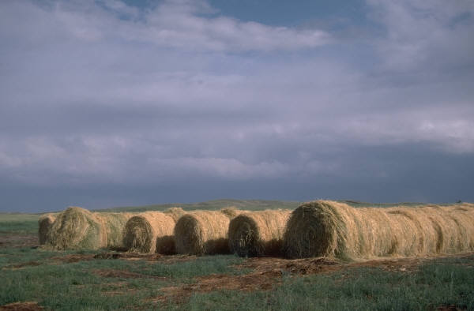

Georgia Farm Bureau
2021 Quality Hay Contest
Entry Form
Open to Georgia Farm Bureau members only

DATE_____________________________COUNTY_____________________
NAME ______________________________PHONE_____________________

FARM NAME ___________________________________________________

ADDRESS _____________________________________________________

CITY_______________________________________Zip_________________

EMAIL_____________________________________________

TYPE/VARIETY OF BERMUDAGRASS HAY SUBMITTED:

Signed_____________________Membership#_____________Date________
(Member)

Member certified by _________________________Date_________________

_____________________County Farm Bureau Office

ENTRY DEADLINE IS OCTOBER 31, 2021.

Place sample of each entry in a one-gallon zip-lock bag. You can take your entry form and sample to your local county Farm Bureau office or mail with your check for $20 for each entry payable to:

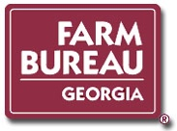
Georgia Farm Bureau
Public Policy Department
1620 Bass Road
Macon, Ga. 31210

